Over/Under Volt_Fault

Author: Daniel
Reviewer: Eason

FAQ/ EVC
Issue introduction
EVC reports UnderVolt_Fault.
Confirmation of basic information
[Photo]SN number of the EVC
Guidance for installer
Step1: Measure the AC terminal line voltage and phase voltage of the EVC.
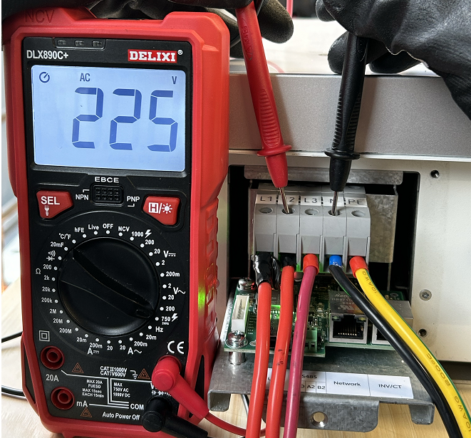 | 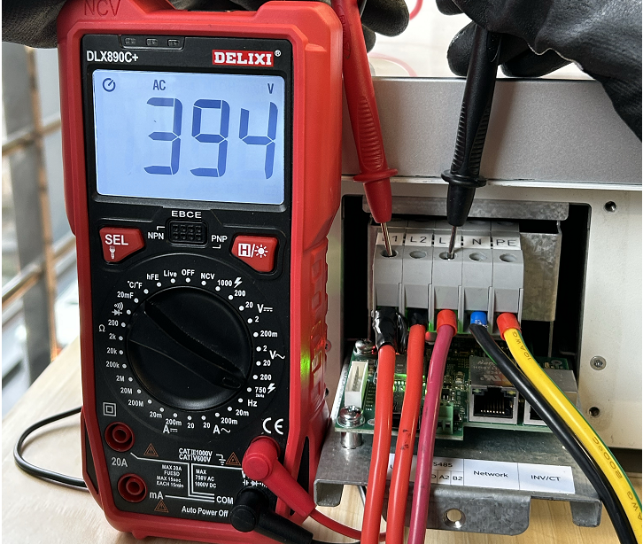
Phase voltage on the grid side | grid line voltage(line voltage＝√3×Phase voltage)
Step2: Upgrade the EVC to the latest firmware version, then turn off the power and turn it on again.
Information check list
If you have completed the above <Guidance for installer>, and the problem is still not solved, please collect the following troubleshooting information and send them to the R&D.
1.[Photo]EVC information including SN and registration numbers.
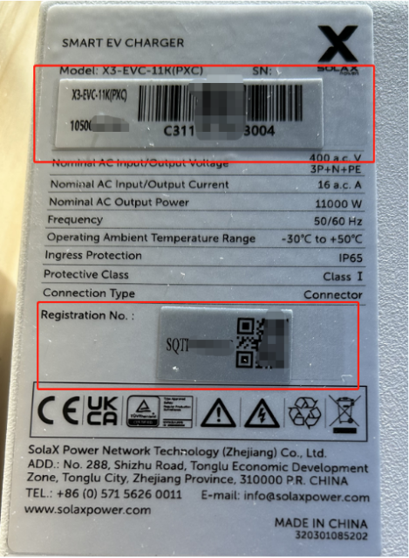
2.[Photo]Phase voltage and line voltage at AC side.
 | 
Phase voltage on the grid side | grid line voltage(line voltage＝√3×Phase voltage)

